PRESS RELEASE
Artisan Creative unveils innovative audience engagement tool for debut Edinburgh Fringe show
Derbyshire-based arts organisation, Artisan Creative, is set to make a resounding impact at Edinburgh Fringe in August. Their unique and uplifting show, "How to Survive and Thrive in an Impossible World - with a piano!" promises to captivate audiences with its mischievousness, subversiveness, and wisdom. And it has just been announced that audiences will also be able to explore the themes and ideas of the show in very different way.

Inspired by the acclaimed book of the same name by award-winning psychologist, author, and songsmith, Steve Bonham, "How to Survive and Thrive in an Impossible World - with a piano!" has been crafted to bring laughter and enlightenment to a world that often feels bonkers. The interactive, wellbeing-infused musical experience invites audiences to step back, revel in life's absurdities, and discover a better way of navigating through it all.

As anticipation builds, Artisan Creative is excited to introduce the “HTSAT Lab”. This is an online toolbox through which people and audiences can engage with the ideas and themes of the show in a different and immersive way.
The first tool in the box is the “Wholeself Questionnaire”. This allows individuals to delve deeper into one of the key ideas explored in the show, offering a unique opportunity for self-reflection and engagement. Participants will gain valuable insights and practical strategies to navigate an impossible world while cultivating personal happiness and wellbeing.
Artisan Creative extends an invitation to journalists to experience the Wholeself Questionnaire Beta version firsthand. By engaging with this novel piece of theatre, journalists will gain a personal understanding of the transformative potential of "How to Survive and Thrive in an Impossible World - with a piano!" and be able to share their insights and reflections with their readers.
To participate in the Wholeself Questionnaire and explore the unique perspective it offers, please visit htsatlab.co.uk. We believe this immersive experience will enhance your understanding of the show and provide an exciting angle for your coverage.
As the countdown begins for the show's Edinburgh run, Artisan Creative aims to capture the attention of arts and community venue programmers from across the country. This extraordinary production serves as a springboard for national touring in 2023 and 2024, spreading its infectious joy and wisdom far and wide.

The show runs at Greenside @ Infirmary Street, at 13.50,
from Friday 4 August to Saturday 19 August (not 13 Aug).
Audiences can expect an unforgettable experience that combines music, laughter, and thought-provoking insights into the human condition.
Join Artisan Creative on their remarkable journey to liberate happiness and wellbeing—one audience, one journalist, and one self at a time! Don't miss the opportunity to engage with this groundbreaking show and experience the transformative power of the Wholeself Questionnaire.
Visit the HTSAT lab: htsatlab.co.uk | Buy tickets from bit.ly/HTSATfringetix | More details at htsat.co.uk
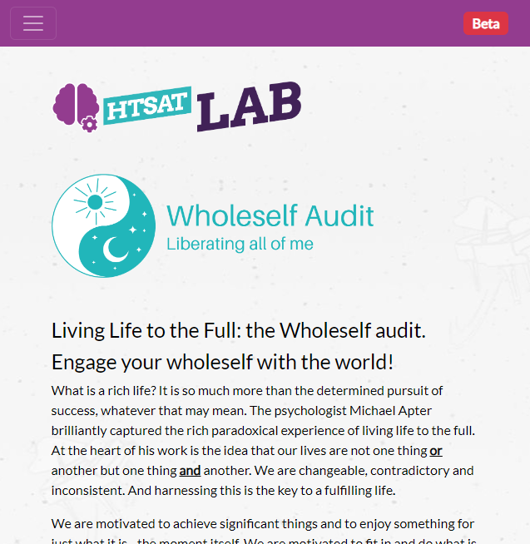

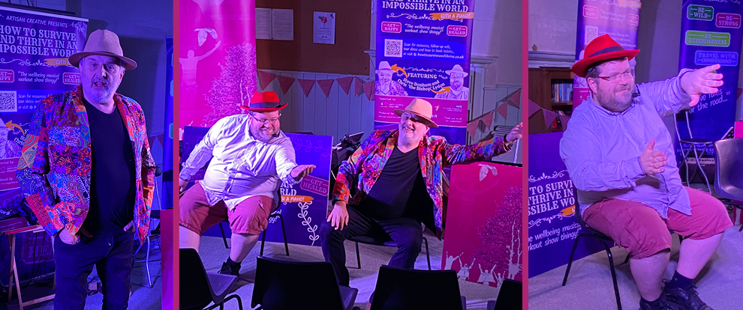

- ENDS -

Background
Artisan Creative
Artisan Creative develops distinctive books, recordings and performances, including new theatre pieces, gigs, concerts and festivals, all celebrating the 'extraordinary stories of ordinary folk', rooted in the values of craft, authenticity, inspiration and a love of the raw materials used. Based on over 30 years of experience of working with professional and non-professional collaborators, they have delivered everything from large-scale community projects to intimate solo performances.
artisan-creative.com

Contacts and further information
Steve Bonham steve@artisan-creative.com 07711 788248
Chris Lydon chris@artian-creative.com 07816 996769

More about How To Survive and Thrive in an Impossible World – with a piano! at htsat.co.uk
More about Artisan Creative at artisan-creative.com

Photographs, logos etc. available from htsat.co.uk/about/press

